

Software Requirements Specification

Project Title

Version 1.0

Printing Date

Department and Faculty

Revision Page
- Overview
Describe the content of the current version.

- Target Audience
State the targeted audience.

- Project Team Members
List the team members and respective assigned module.

- Version Control History
Version | Primary Author(s) | Description of Version | Date Completed
<Current Version>

Note:
This Software Requirements Specification (SRS) template is based on IEEE Std 830-1998, organized by modules according to system features (Appendix A.5 of the IEEE Std, 830-1998, Section 5) and customized to meet the need of SCSJ2203 course at Faculty of Computing, UTM. Compiled and checked by Shahida Sulaiman, PhD on 20 March 2016. Examples of models are from Satzinger (2011).

Table of Contents
1 | Introduction |  |  |  |  | 1
 | 1.1 | Purpose |  |  |  | 1
 | 1.2 | Scope
 | 1.3 | Definitions, Acronyms and Abbreviations
 | 1.4 | References
 | 1.5 | Overview
2 | Overall Description
 | 2.1 | Product Perspective
 |  | 2.1.1 | System Interfaces
 |  | 2.1.2 | User Interfaces
 |  | 2.1.3 | Hardware Interfaces
 |  | 2.1.4 | Software Interfaces
 |  | 2.1.5 | Communication Interfaces
 |  | 2.1.6 | Memory
 |  | 2.1.7 | Operations
 |  | 2.1.8 | Site Adaptations Requirements
 | 2.2 | Product Functions
 | 2.3 | User Characteristic
 | 2.4 | Constraints
 | 2.5 | Assumption and Dependencies
 | 2.6 | Apportioning of Requirements
3 | Specific Requirements
 | 3.1 | External Interface Requirements
 |  | 3.1.1 |  | User Interfaces
 |  | 3.1.2 |  | Hardware Interfaces
 |  | 3.1.3 |  | Software Interfaces
 |  | 3.1.4 |  | Communication Interfaces
 | 3.2 | System Features
 |  | 3.2.1 |  | Module <Name of Module1>
 |  |  |  | 3.2.1.1 | UC001: Use Case <Name of Use Case1>
 |  |  |  | 3.2.1.2 | UC002: Use Case <Name of Use Case2>
 |  |  |  | 3.2.1.3 | UC003: Use Case <Name of Use Case3>
 |  | 3.2.2 |  | Module <Name of Module2>
 |  |  |  | 3.2.1.1 | UC004: Use Case <Name of Use Case4>
 |  |  |  | 3.2.1.2 | UC005: Use Case <Name of Use Case5>
 |  | 3.2.n |  | Module <Name of the n Module>
 | 3.3 | Performance Requirements
 | 3.4 | Design Constraints
 | 3.5 | Software System Attributes
 | 3.6 | Other Requirements
Appendices (if any)

- Introduction
The following section and subsections of the Software Requirement Specifications (SRS) document should provide the details of the entire SRS. Remove the notes in read texts including these notes.

  - Purpose
This subsection should:
- Delineate the purpose of the SRS;
- Specify the intended audience for the SRS.

This SRS describes…

  - Scope
This subsection should:
- Identify the software product(s) to be produced by name (e.g., Host DBMS, Report Generator, etc.);
- Explain what the software product(s) will, and, if necessary, will not do;
- Describe the application of the software being specified, including relevant benefits, objectives, and goals;
- Be consistent with similar statements in higher-level specifications (e.g., the system requirements specification), if they exist.

The software product is…

  - Definitions, Acronyms and Abbreviation
This subsection should provide the definitions of all terms, acronyms, and abbreviations required to properly interpret the SRS. This information may be provided by reference to one or more appendixes in the SRS or by reference to other documents.

Definitions of all terms, acronyms and abbreviation used are to be defined here.

  - References
This subsection should:
- Provide a complete list of all documents referenced elsewhere in the SRS;
- Identify each document by title, report number (if applicable), date, and publishing organization;
- Specify the sources from which the references can be obtained.

Specify complete list of references using a standardized reference format.

  - Overview
This subsection should:
- Describe what the rest of the SRS contains;
- Explain how the SRS is organized.

Give an overview of the content of this SRS document.

- Overall Description
This section of the SRS should describe the general factors that affect the product and its requirements. This section does not state specific requirements. Instead, it provides a background for those requirements, which are defined in detail in Section 3 of the SRS, and makes them easier to understand.
Describe the general factors that affect the products and its requirements. Provides background for those requirements.

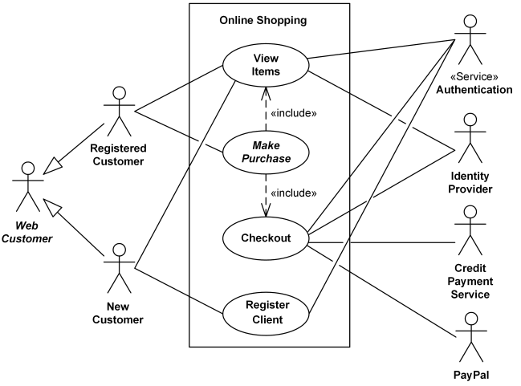

Figure 2.1: Use Case Diagram of <Name of the System>

  - Product Perspective
This subsection of the SRS should put the product into perspective with other related products. If the product is independent and totally self-contained, it should be so stated here. If the SRS defines a product that is a component of a larger system, as frequently occurs, then this subsection should relate the requirements of that larger system to functionality of the software and should identify interfaces between that system and the software.

A block diagram (such as context diagram) showing the major components of the larger system, interconnections, and external interfaces can be helpful.
Explain the perspective of the software product here.

    - System Interfaces
This should list each system interface and identify the functionality of the software to accomplish the system requirement and the interface description to match the system.
[Users or other systems interfacing with the system and each function based on the use case diagram]
List here...

    - User Interfaces
This should specify the following:
- The logical characteristics of each interface between the software product and its users.
This includes those configuration characteristics (e.g., required screen formats, page or window layouts, content of any reports or menus, or availability of programmable function keys) necessary to accomplish the software requirements.
- All the aspects of optimizing the interface with the person who must use the system.
This may simply comprise a list of do’s and don’ts on how the system will appear to the user. One example may be a requirement for the option of long or short error messages. Like all others, these requirements should be verifiable, e.g. “A clerk typist grade 4 can do function X in Z min after 1 h of training” rather than “a typist can do function X.” (This may also be specified in the Software System Attributes under a section titled Ease of Use.)
Describe how the system will interact with its users.

    - Hardware Interfaces
This should specify the logical characteristics of each interface between the software product and the hardware components of the system. This includes configuration characteristics (number of ports, instruction sets, etc.). It also covers such matters as what devices are to be supported, how they are to be supported, and protocols. For example, terminal support may specify full-screen support as opposed to line-by-line support.
Specify the logical characteristic here…

    - Software Interfaces
This should specify the use of other required software products (e.g., a data management system, an operating system, or a mathematical package), and interfaces with other application systems (e.g., the linkage between an accounts receivable system and a general ledger system). For each required software product, the following should be provided:
- Name;
- Mnemonic;
- Specification number;
- Version number;
- Source.

For each interface, the following should be provided:
- Discussion of the purpose of the interfacing software as related to this software product.
- Definition of the interface in terms of message content and format. It is not necessary to detail any

Well-documented interface, but a reference to the document defining the interface is required.

Specify here…

    - Communication Interfaces
This should specify the various interfaces to communications such as local network protocols, etc.
Specify here…

    - Memory
This should specify any applicable characteristics and limits on primary and secondary memory.
Specify here...

    - Operations
This should specify the normal and special operations required by the user such as:
- The various modes of operations in the user organization (e.g., user-initiated operations);
- Periods of interactive operations and periods of unattended operations;
- Data processing support functions;
- Backup and recovery operations.
Note: This is sometimes specified as part of the User Interfaces section.
Specify the operations here...

    - Site Adaptation Requirements
This should:
- Define the requirements for any data or initialization sequences that are specific to a given site, mission, or operational mode (e.g., grid values, safety limits, etc.);
- Specify the site or mission-related features that should be modified to adapt the software to a particular installation.

Define and specify here...

  - Product Functions
This subsection of the SRS should provide a summary of the major functions that the software will perform. For example, an SRS for an accounting program may use this part to address customer account maintenance, customer statement, and invoice preparation without mentioning the vast amount of detail that each of those functions requires.
Sometimes the function summary that is necessary for this part can be taken directly from the section of the higher-level specification (if one exists) that allocates particular functions to the software product. Note that for the sake of clarity:
- The functions should be organized in a way that makes the list of functions understandable to the customer or to anyone else reading the document for the first time.
- Textual or graphical methods can be used to show the different functions and their relationships. Such a diagram is not intended to show a design of a product, but simply shows the logical relationships among variables.

Summarize the major functions (by use case) of the system by referring to the use case diagram, Figure 2.1.

  - User Characteristics
This subsection of the SRS should describe those general characteristics of the intended users of the product including educational level, experience, and technical expertise. It should not be used to state specific requirements, but rather should provide the reasons why certain specific requirements are later specified in Section 3 of the SRS.
Describe here...

  - Constraints
This subsection of the SRS should provide a general description of any other items that will limit the developer’s options. These include:
- Regulatory policies;
- Hardware limitations (e.g., signal timing requirements);
- Interfaces to other applications;
- Parallel operation;
- Audit functions;
- Control functions;
- Higher-order language requirements;
- Signal handshake protocols (e.g., XON-XOFF, ACK-NACK);
- Reliability requirements;
- Criticality of the application;
- Safety and security considerations.

State here…

  - Assumption and Dependencies
This subsection of the SRS should list each of the factors that affect the requirements stated in the SRS. These factors are not design constraints on the software but are, rather, any changes to them that can affect the requirements in the SRS. For example, an assumption may be that a specific operating system will be available on the hardware designated for the software product. If, in fact, the operating system is not available, the SRS would then have to change accordingly.
List the factors here…

  - Apportioning of Requirements
This subsection of the SRS should identify requirements that may be delayed until future versions of the system.
Identify and state here…

- Specific Requirements
This section of the SRS should contain all of the software requirements to a level of detail sufficient to enable designers to design a system to satisfy those requirements, and testers to test that the system satisfies those requirements. Throughout this section, every stated requirement should be externally perceivable by users, operators, or other external systems. These requirements should include at a minimum a description of every input (stimulus) into the system, every output (response) from the system, and all functions performed by the system in response to an input or in support of an output.
[Include domain model i.e. class diagram without the operation part – only attributes without details on visibility and type, explain each class and its attributes including the relationships among the classes, see the example of Customer Support System. For the class with the states, consider to include its state machine diagram, see the example for state machine diagram of OrderItem class]
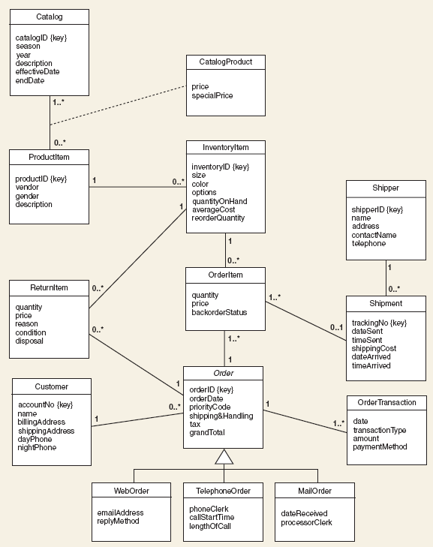
Figure 3.1: Domain Model of <Name of the System>
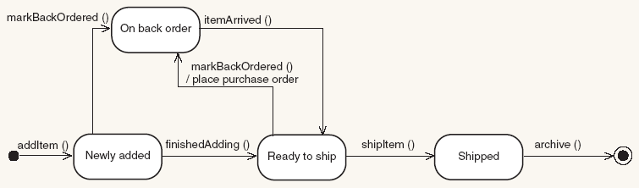
Figure 3.2: State Machine Diagram of <Name of the Class>

As this is often the largest and most important part of the SRS, the following principles apply:
- Specific requirements should be stated in conformance with all the characteristics described in 4.3. (IEEE Std 830-1998)
- Specific requirements should be cross-referenced to earlier documents that relate.
- All requirements should be uniquely identifiable. [Provide ID to each functional requirement]
- Careful attention should be given to organizing the requirements to maximize readability.
[Section 3.1.1 to Section 3.1.4 provide the details of what described in 2.1.2 to 2.1.5. Consider to organize Section 3.2 by the modules i.e. map each feature with each module and map respective use case in the module with its functional requirement. For each functional requirement, indicate its details using use case description. Include sequence diagram (of system level also known as system sequence diagram) and activity diagram for each use case i.e. functional requirement.]
  - External Interface Requirements
    - User Interfaces
Provide the details for Section 2.1.2.

    - Hardware Interfaces
Provide the details for Section 2.1.3.

    - Software Interfaces
Provide the details for Section 2.1.4.

    - Communication Interfaces
Provide the details for Section 2.1.5.

  - System Features
    - Module <Name of Module1>
State briefly the functional requirements (use cases) that are available in this module. Better to include the diagram of the specific module (or the example of Customer Support System – by subsystem, see example below) from the overall use case diagram in Figure 2.1.
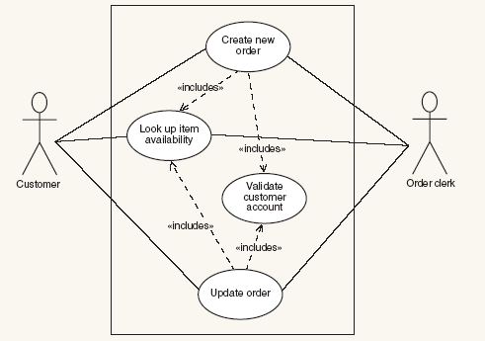
Figure 3.2: <Name of the Module/Sub-System e.g. Order Entry Subsystem>

      - UC001: Use Case <Name of Use Case1>
Provide code for each use case such as UC001 and so on… Include Use Case Description for each use case as in the example below. Ensure each use case has its own unique ID and the name of the heading above corresponds to the name of use case in the use case diagram (refer to Figure 2.1). Different scenarios of a use case require separate use case descriptions.

Table 3.1: Use Case Description for <Name of Use Case>
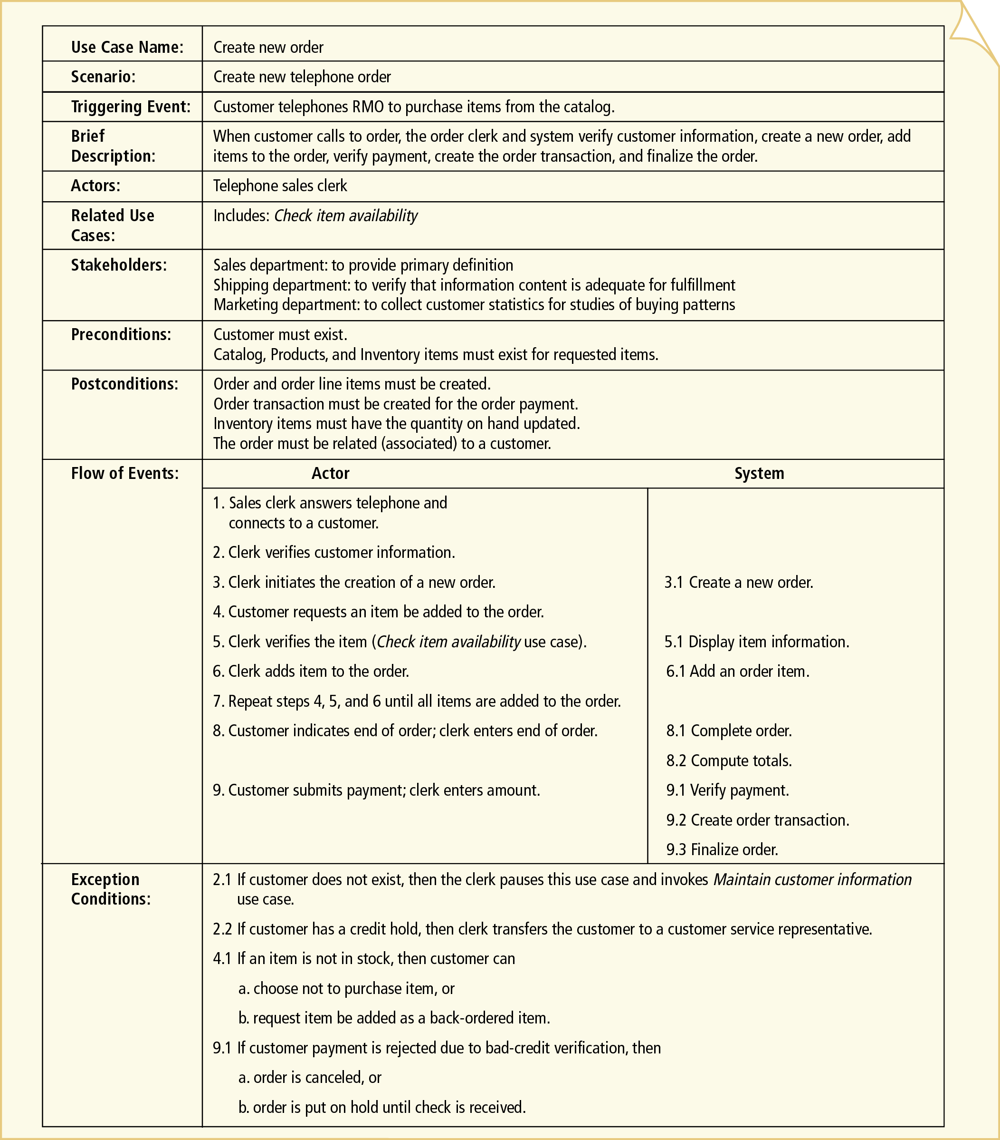
Include system sequence diagram and activity diagram for each respective use case. See example below for Telephone Order scenario of Create New Order use case for both diagrams. Consider to include different scenarios example telephone vs. Web order scenario in different diagrams if applicable.

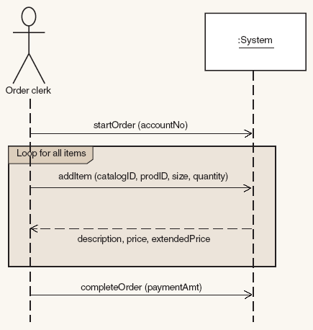
Figure 3.3: System Sequence Diagram of <Name of Use Case/Scenario if more than one scenario>
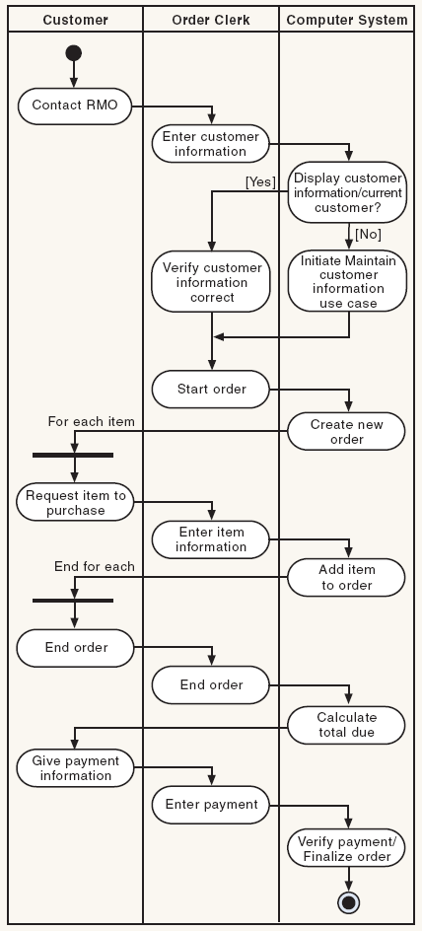
Figure 3.4: Activity Diagram of <Name of Use Case/Scenario if more than one scenario>

      - UC002: Use Case <Name of Use Case2>
      - UC003: Use Case <Name of Use Case3>

    - Module <Name of Module2>
      - UC004: Use Case <Name of Use Case4>
      - UC005: Use Case <Name of Use Case5>

3.2.n Module <Name of the n Module>
…
  - Performance Requirements
State and refer to the specific functional requirement that is related to this non-functional requirement (if any).

  - Design Constraints
Explain any constraints imposed by the organization where the software product will be used such as the system must adhere to certain organizational standard and other related non-functional requirements.

  - Software System Attributes
Indicate any specific attributes that the customers/users request such as system must be attractive and easy to use for any specific customers.

  - Other Requirements
State here other quality characteristics or non-functional requirements for either customers/users or developers such as adaptability, flexibility, interoperability, maintainability, portability, reliability, reusability and usability.

